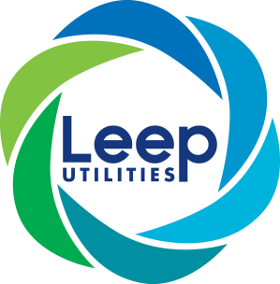
Leep Electricity Networks Limited The Greenhouse, MediaCityUK, Salford, M50 2EQ.
Tel: 0345 122 6786

Louise Van Rensburg
Ofgem
10 South Colonnade
Canary Wharf
London
E14 4PU

By email – flexibility@ofgem.gov.uk

25 March 2022

Dear Louise,

Flexibility Procurement Statement

Leep Electricity Networks Ltd is a young IDNO business with circa 6,000 energised connections, mainly operating LV and 11Kv radial and isolated networks. Our strategy is to work with single developers to undertake schemes designed to the requirements of the development to meet the capacity required and therefore our networks are not currently under or over capacity.

We have reviewed requirements relating to the procurement of flexibility services for the coming year of 2022-23 and have reached the following conclusions:

- Given the sites we currently serve and our future connections strategy, we do not have the technical need to be able to increase or decrease neither generation nor demand
- Due to the nature of the engineering surrounding our sites minimal flexibility is required given that networks or constructed to meet the capacity needed
- The nature of current demands are known and catered for therefore any potential demand management or flexibility is minimal

As such we do not intend to procure any flexibility services during 2022-23 however will continue to monitor and appraise this situation, should the need arise.

Should you require any further detail to support our current position, please contact me on 07391 866484.

Yours sincerely

Vicky Bell
Head of Regulation and Compliance
For Leep Electricity Networks Limited

